INTERPHASE | DNA duplicates.  Organelles duplicate. | 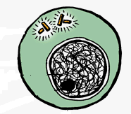
PROPHASE | Nuclear membrane breaks down.  Chromosomes appear.  Spindle apparatus forms. | 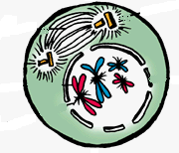
METAPHASE | Chromosomes line up at equator of  cell.  Centromeres attach to spindle fibres. | 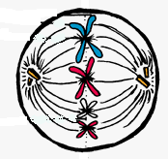
ANAPHASE | Chromosomes split, chromatids  move to opposite poles of cell. | 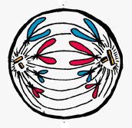
TELOPHASE | Spindle apparatus breaks down.  Nuclear membranes form. | 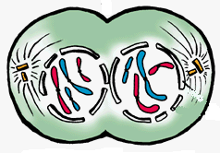
CYTOKINESIS | Cytoplasm splits between both cells.  Two daughter cells are formed. | 

